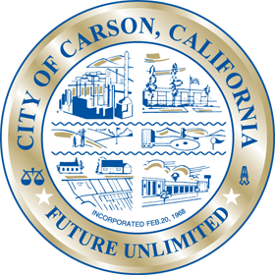
City of Carson

The Environmental Commission went dark for the month of October.

